**ME222A**

*Department of Mechanical Engineering*

LAB REPORT (A3)

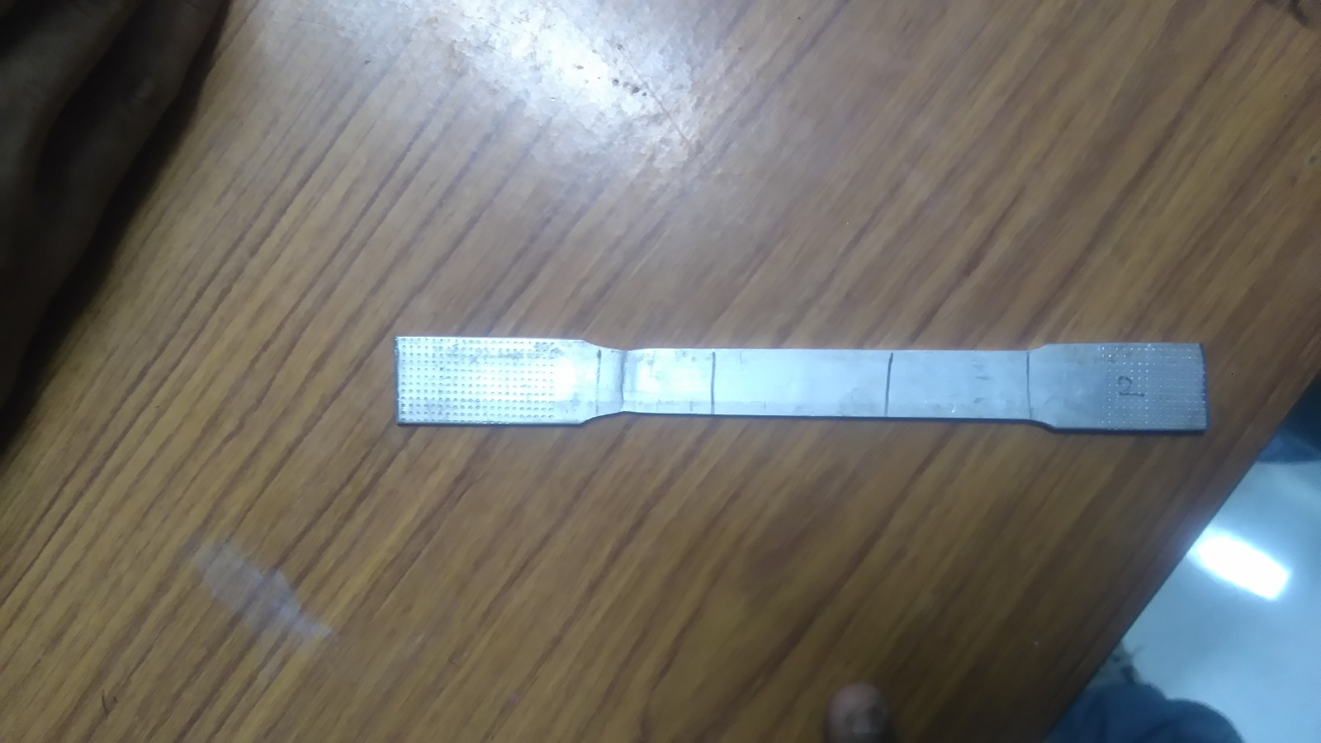

Study of Young’s modulus with strain gauge for MS and Al

ARVIND PRASAD 150141 Instructor: Prof. B Bhattacharya

ASHISH YADAV 150148

ASIM KATAKWAR 150159 Date of Experiment: 17/02/2017

AVINASH KUMAR 150169 Date of Submission: 24/02/2017

AYUSH SINGH 150177

BHANUPRATAP NIRANJAN 150182

**AIM**

Studies of Young’s modulus with strain gauge for MS and Al. Also to identify the type of fracture (DUCTILE /BRITTLE) and to acknowledge change in characteristics of stress and strain with change in strain rate.

**INTRODUCTION**

The knowledge of elastic constant of materials is indispensable for structure design and quality control purposes. Thus its determination is of utmost importance to all engineering applications. The Young’s modulus or modulus of elasticity E is the property which describes the deformation behaviour of a material or structure under loading. Materials deform differently when loads are applied, and the relationship between stress and strain is typically defined by the Young’s modulus. The ability of any material to resist or transmit load is important, and this property is often used to determine if a particular material is suitable for a specific purpose.

The quantity employed in the evaluation of structural parts is the mechanical stress to which the material is subjected. Mechanical stresses are virtually impossible to determine under operational conditions. A practical method for the experimental determination of material stresses is based on a discovery made by the English scientist *Robert Hooke*. He found a relationship between the material stress and the resulting deformation. This deformation, called “strain”, also occurs on the surface of objects and is therefore accessible for measurement. An important branch of experimental stress analysis is based on the principle of strain measurement. Mostly, the Young’s modulus E is derived from the slope of the linear part of the stress-strain curve during uniaxial tensile testing.

During 1938 in the USA, two people were working almost simultaneously but independently, on the idea of using the “Thomson effect” for measurement purposes. The development, which led to the strain gauge and its subsequent wide spread application.

Strain gauges are manufactured in a multitude of different types, providing a method that can be matched to various measurement tasks, even under arduous conditions. The main areas of application for strain gauges are:-

Experimental stress analysis, including model measurement techniques and biomechanics.

Transducer manufacture. Whereas the strain gauge's adaptability contributed to its widespread use in the field of experimental stress analysis, it was the high degree of measurement accuracy that could be obtained which made the strain gage attractive for transducer manufacture. Both wound wire and foil types produce strain gauges which are known as metal strain gauges due to their metal alloy measuring grids.

**THEORY**

Stress: σ **=** F/A (N/m2)

Where F = force (load) and A is the cross-sectional area (width * thickness) of the gauge section.

Engineering Stress: σ **=** F/A0

Where A0 = initial cross-sectional area

True stress: σ = F/A­­t

Where At = instantaneous cross-sectional area.

Strain: ε = ΔL/L0 (dimensionless)

Where ΔL is the elongation and L0 is the original gauge length.

Young’s Modulus:

E = σ (ε)/ ε = FL0 /A0 Δ L

**PROCEDURE**

1. Obtain the required testing specimens materials (1 Al sample & 2 steel sample of different thickness)
2. Measure dimensions of the sample using vernier caliper: width, thickness and gage length (axial length in which the diameter, width, or thickness is constant).
3. Install one of the test specimen (say Al) into the test machine by threading the ends into the jaws on the testing machine.
4. Use the manual “UP” and “DOWN” buttons to position the crosshead such that the specimen no longer has any lose or play, but is not yet under tension.
5. Now start the machine and open the software on the computer attached with the machine.
6. Open a new file, name it and enter all the details of the specimen.
7. Set up a particular strain rate and click on start button.
8. Stop the machine when fracture occur in the specimen and collect the stress vs strain vs time data of the specimen.
9. Mark carefully the points corresponding to the

* Yield points
* Maximum stress
* Fracture stress
* Plastic region
* Elastic region
* Proportional limit
* Elastic limit, etc.

Calculate the:

* Engineering stress/extension ratio
* True stress/ strain
* True stress/extension ratio curves from the engineering stress/strain curve and draw it on the same figure as the engineering stress/strain curve.

Repeat the same procedure for steel samples.

**SPECIMEN DIMENSION & GEOMETRY**

Sample width (mm):

|  |  |  |  |  |
| --- | --- | --- | --- | --- |
|  | Aluminium (1) | Aluminium (2) | Mild Steel (3) | Mild Steel (4) |
| 1. | 14.70 | 16.0 | 13.54 | 14.44 |
| 2. | 14.60 | 16.90 | 10.66 | 12.00 |
| 3. | 14.72 | 15.80 | 11.20 | 12.22 |
| 4. | 15.60 | 15.00 | 13.84 | 13.74 |
| Mean | 14.65 | 15.90 | 12.31 | 13.10 |

Sample Thickess(mm):

|  |  |  |  |  |
| --- | --- | --- | --- | --- |
|  | Aluminium (1) | Aluminium (2) | Mild Steel (3) | Mild Steel (4) |
| 1. | 3.32 | 3.34 | 3.60 | 2.76 |
| 2. | 3.24 | 3.30 | 3.56 | 2.72 |
| 3. | 3.30 | 3.44 | 3.66 | 2.66 |
| 4. | 3.30 | 3.30 | 3.70 | 2.60 |
| Mean | 3.29 | 3.34 | 3.63 | 2.68 |

Sample dimensions:

|  |  |  |  |  |
| --- | --- | --- | --- | --- |
|  | Aluminium 1 | Aluminium 2 | Mild Steel 3 | Mild Steel 4 |
| Gauge Length (mm) | 86.5 | 82.5 | 75.0 | 88.0 |
| Mean Cross section area (mm2) | 48.2 | 53.1 | 44.7 | 35.1 |

Sample strain rate (mm/min):

|  |  |  |  |  |
| --- | --- | --- | --- | --- |
|  | Aluminium 1 | Aluminium 2 | Mild Steel 3 | Mild Steel 4 |
| Elastic Zone | 5 | 10 | 5 | 10 |
| Plastic Zone | 5 | 10 | 5 | 10 |

**RESULTS:**

Aluminium 1

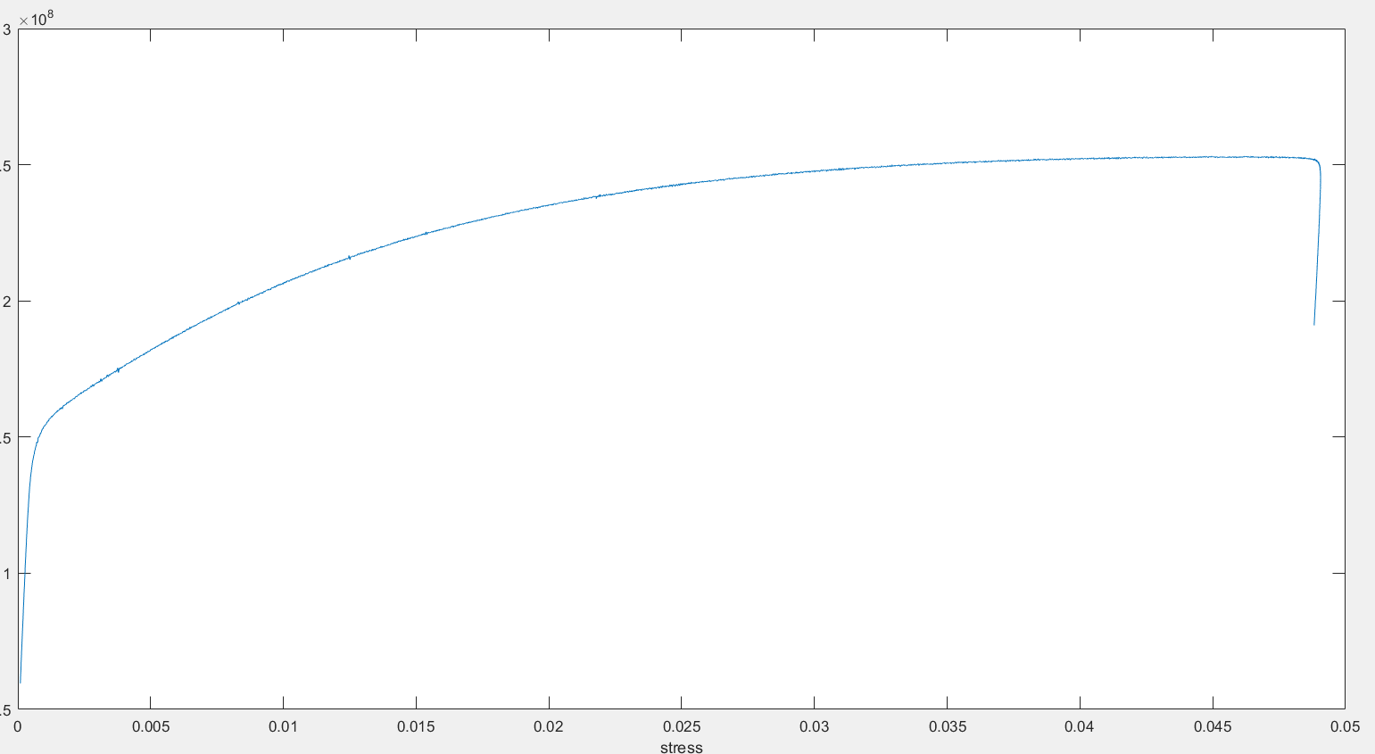

Here, Young’s modulus from graphical analysis is

E = Stress/Strain (Slope of stress strain curve)

= (y2 – y­1 ) / (x2 – x1) = (1.485-0.6838)*108/(0.05568-.05504)

=125 GPa

Aluminium 2

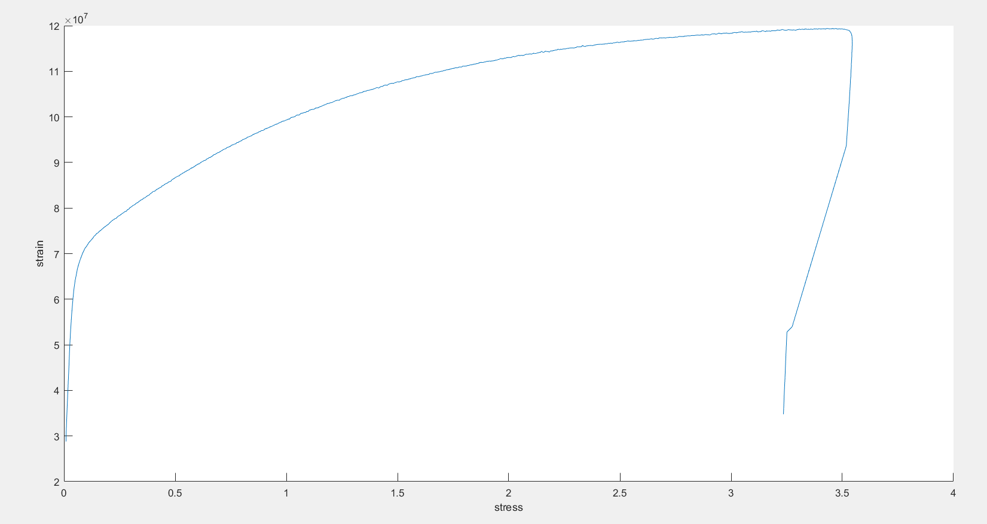

Mild Steel 1

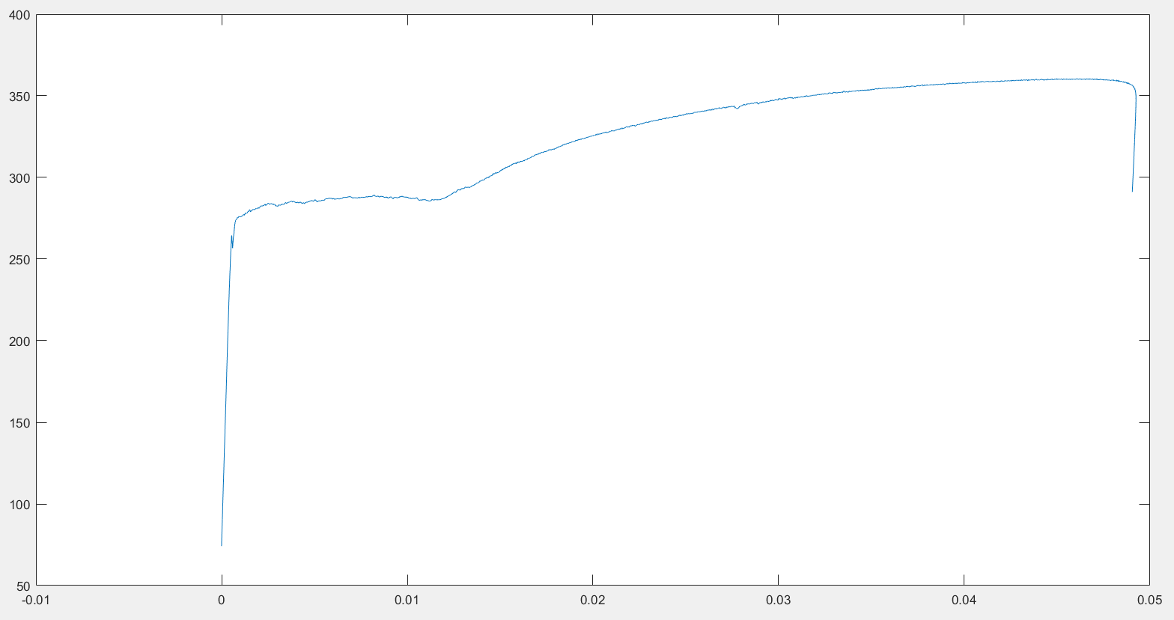

Here, Young’s modulus from graphical analysis is

E = Stress/Strain (Slope of stress strain curve)

= (y2 – y­1 ) / (x2 – x1) = (3.949-1.231)*108/(0.0007246-0.0002192)

=537 GPa

Mild Steel 2

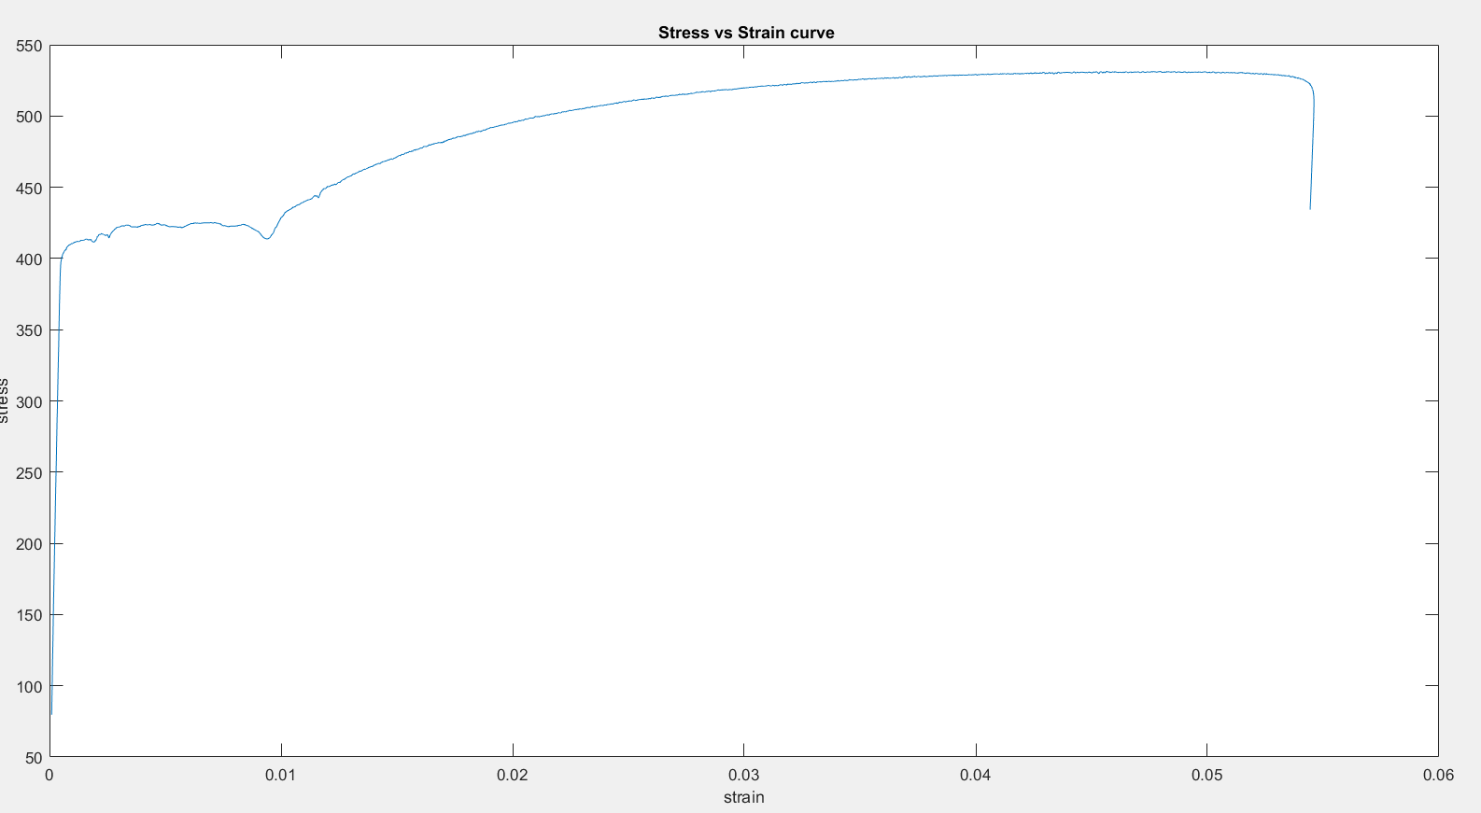

Here, Young’s modulus from graphical analysis is

E = Stress/Strain (Slope of stress strain curve)

= (y2 – y­1 ) / (x2 – x1) = (3.719-1.43)*108/(0.0007671-0.0002898)

=479 GPa

Mild Steel 1 & 2

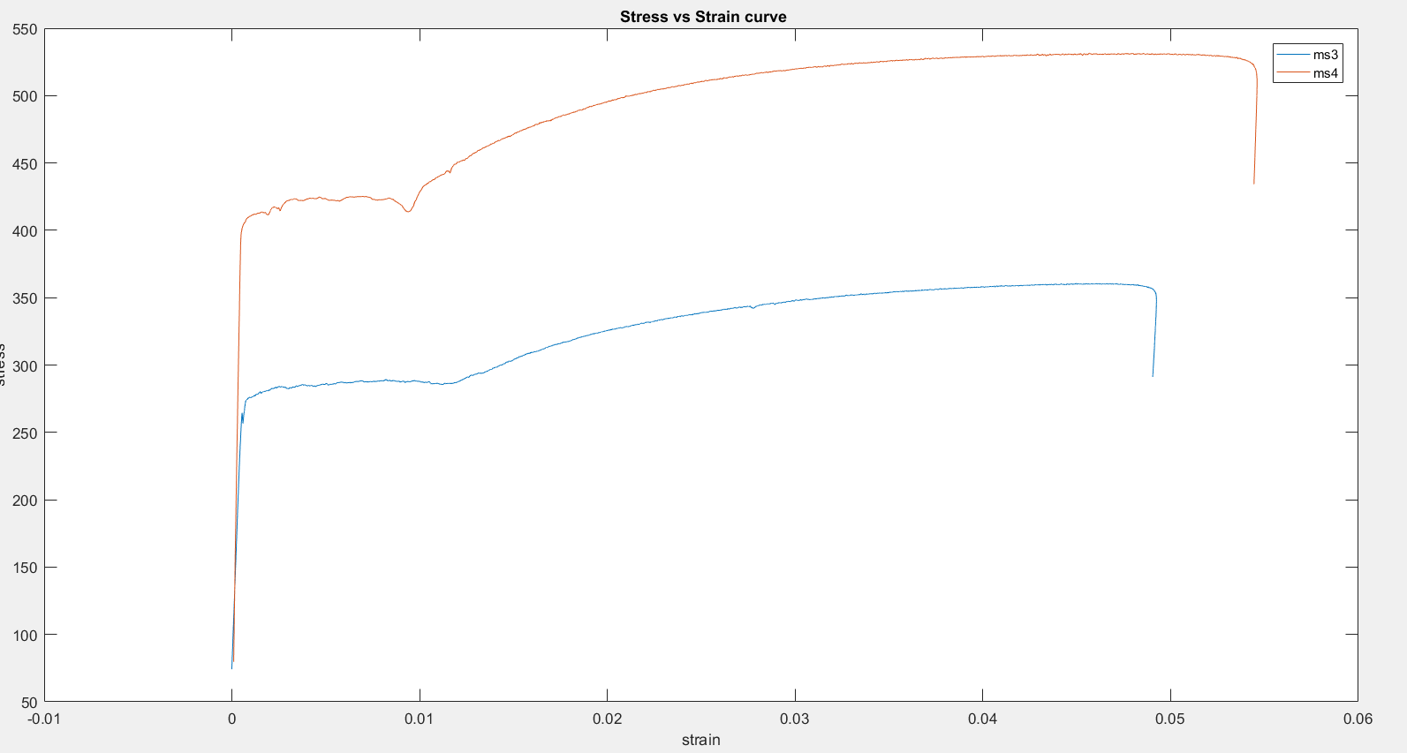

**DISCUSSION**

**Does young’s modulus depends on strain rate?**

As it is evident from graph number four that young’s modulus for same material does not depends on the strain rate of the strain gauge as the slopes of MS1 and MS 2 almost coincide.

**Type of fracture**

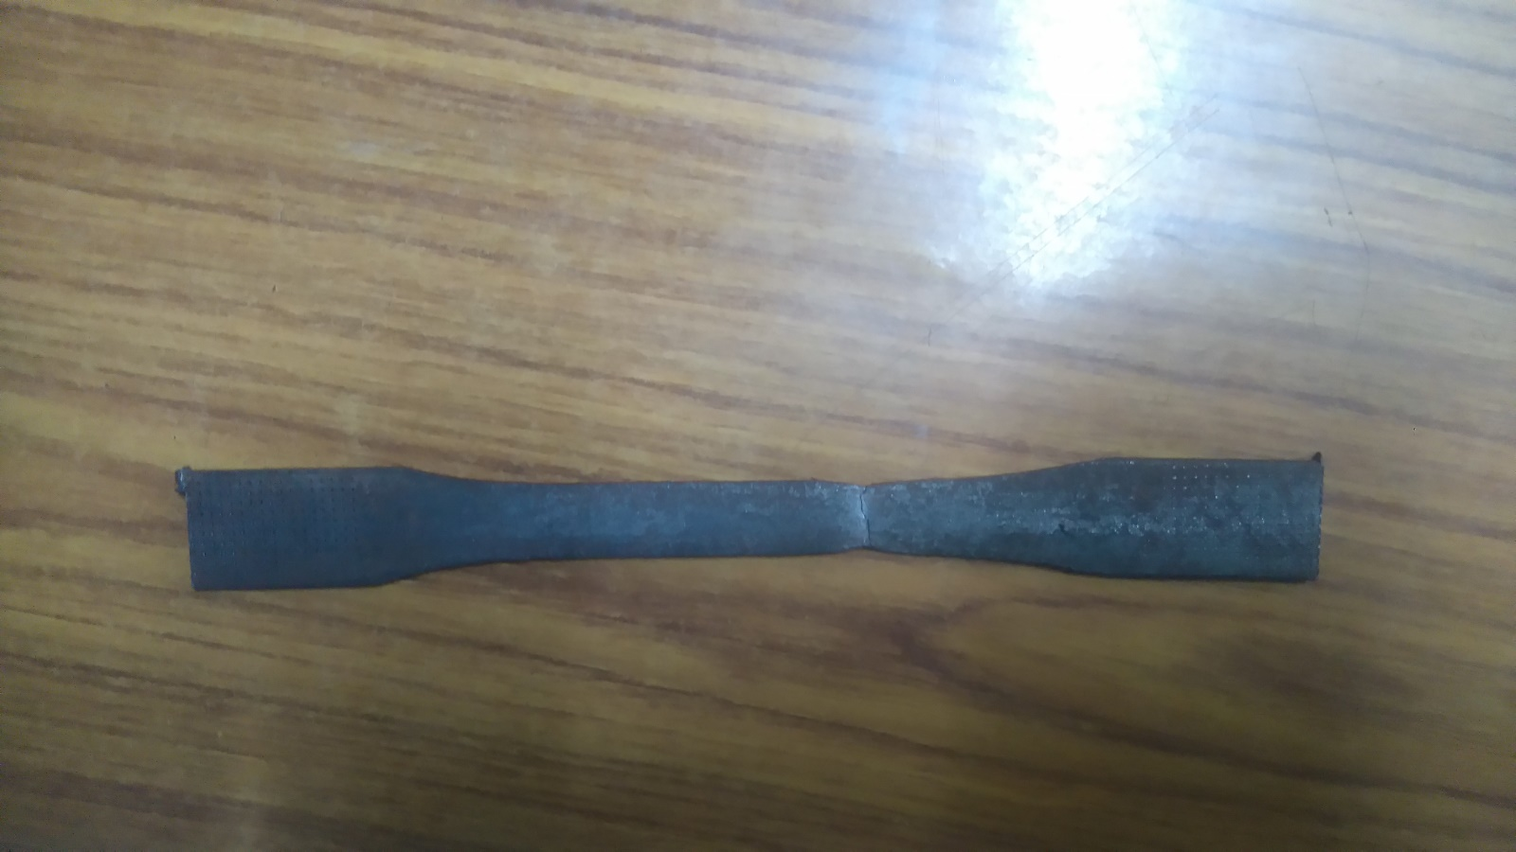

Clearly there is a plastic deformation at the point of fracture of the specimen, hence, the type of fracture occurred here is Ductile Fracture.

**CONCLUSION**

In this experiment we measured yield strength, ultimate Tensile strength, young’s modulus, toughness, stiffness etc. of materials like steel and aluminium

We note that aluminium have very less strength as compared to steel. The deformation region ends with sudden fracture.

**PRECAUTIONS**

* A paper should be placed above and below the specimen so that machine does not get damaged.
* Care should be taken while changing the fixtures in the machines.
* Dimensions of the specimen should be measured and entered in the machine carefully.

**REFERENCES**

* Materials Science and Engineering, An Introduction (Eighth Edition) by William D. Callister, Jr. and David G. Rethwisch.
* Class Notes Structure and Properties of Materials, ME 222A, Prof. B Bhattacharya & Prof. Kamal K. Kar
* Wikipedia